**Sample Tweets & Facebook posts**

These are template messages to help save you time. Please feel free to adapt, translate and add statistics relevant to your national context.

**Add a twitter handle of a national advocacy target:** In order to achieve the biggest impact, we want to make sure that those we are seeking to influence hear our messages loud and clear. So make sure you add a twitter handle of a national advocacy target. This can either be national-level decision-makers (Head of State, Finance Minister etc.) or your national representative to the UN Commission on the Status of Women in New York.

***TOP TIP 2:*** Don’t use a target person or organization’s twitter handle right at the start of the tweet, otherwise only your target will see the message (and not anyone else). To get around this you can add text before, or a full stop, e.g. “Hello @FinanceMinister...” or “.@FinanceMinister..., and your message will be seen both by the target and the public.

**Every tweet or message below has #TaxJustice included - this should not be removed**. Every tweet also has as an International Women’s Day *and* a UNSCW hashtag -- you can remove one of these if you like - just remember to keep the one that corresponds with the day you are tweeting (see [hashtag](https://docs.google.com/document/d/1_jqEh3O-fwzb9it2emNrdwQwJTYMYzUBIUwnMh8w2Ho/edit#bookmark=id.mpkkp6cekz7l) section above).

***TOP TIP 2:*** You may like to use them in combination with the [social media assets here](https://drive.google.com/drive/folders/0BxZWfVnmDO4pQ2gxUWI2bzdrSXc).

***Remember* to fill in or remove text from [**square brackets**]!**

* If we want to #fightinequality & achieve #genderequality, we need #TaxJustice. Retweet if you agree! #IWD #UNCSW @GA4TJ
* This #WomensDay, women and girls around the world are demanding #TaxJustice for #WomensRights. Join us! RT! #IWD #UNCSW
* When MNCs don’t pay their share, women suffer. Tax pays for #MaternalHealth & upholds #SRHR. #TaxJustice #IWD #UNCSW
* Every $ of tax a company avoids paying is a $ less for public services that protect #WomensRights. #TaxJustice #taxhavens #IWD #UNCSW  
  *[note: can replace $ with sign for shilling/euro/etc.]*
* Forget diamonds, #TaxJustice is a woman’s best friend! #TaxPaysfor childcare, social protection and safe public transport #IWD #UNCSW
* .@[INSERT Twitter handle of your political target] Support for #TaxJustice is support for #womensrights: http://bit.ly/TaxJusticeWR #IWD #UNCSW
* Fetching water can keeps girls from school & women from work. Tax pays for clean, piped water. #GenderEquality requires #TaxJustice #IWD #UNCSW
* Women take on more unpaid care work when public services aren’t adequately funded. #WomensRights need #TaxJustice #IWD #UNCSW
* More girls are out of school than boys worldwide. Tax-funded public schools can lessen this gap. #Girlsrights need #TaxJustice #IWD #UNCSW
* #VAWG affects 1 in 3 women. Tax-funded public services improve women’s safety by providing better policing, street lighting, etc. #TaxJustice#IWD #UNCSW
* We cannot achieve #WomensRights, #GenderEquality or the #SDGs without taking action for #TaxJustice. Here’s why: http://bit.ly/TaxJusticeWR #IWD #UNCSW
* When rich nations and MNCs write the tax rules, we lose funds for #WomensRights & #Equality. We need a @Globaltaxbody. #TaxJustice #IWD #UNCSW
* Please retweet. In [#COUNTRY NAME] we are campaigning for #TaxJustice for #WomensRights #IWD #UNCSW
* 7 Reasons why we need #TaxJustice for #Women’sRights: <http://bit.ly/TaxJusticeWR> #IWD #UNCSW
* Tax injustice is #sexist. Read point 5 to find out why: <http://bit.ly/TaxJusticeWR> #TaxJustice #FightInequality #IWD #UNCSW
* Most maternal deaths can be prevented with more resources. Tax is what pays for public health. #TaxJustice → #WomensRights #globalhealth #IWD #UNCSW
* Most ‘savings’ from #taxbreaks #taxdodging are made by men. #TaxJustice is vital for #GenderEquality #IWD #UNCSW
* How tax is raised and spent affects women more than men. Here’s why:  <http://bit.ly/TaxJusticeWR> #TaxJustice #IWD #UNCSW
* UN finds many National Action Plans for #GenderEquality show up to a 90% funding gap. If we had #TaxJustice govts could fill that gap #IWD #UNCSW
* .@[INSERT Twitter handle of your political target] VAT and privatization are not the funding answers. We need #TaxJustice to fulfill #WomensRights #IWD #UNCSW
* Developing countries lose approx US$138 BILLION in #taxbreaks to MNCs every year - at the expense of #WomensRights. #TaxJustice #IWD #UNCSW

**Sample Facebook Post** 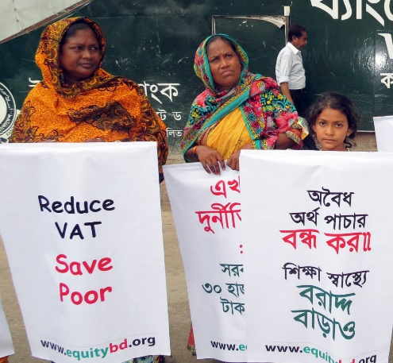

If you fight for women’s rights, you must stand for tax justice too.   
  
When multinational corporations and billionaires dodge or avoid taxes, they are depriving our governments of the funds needed to pay for the public services that are vital to achieving women’s rights and economic equality. As defenders of women’s rights, we must act. We are joining our allies around the world in calling on governments to take action for tax justice!   
Find out how you can join too: <http://www.globaltaxjustice.org/en/action/global-days-action-taxjustice-women%E2%80%99s-rights>